目录

公式 2

默写题 3

week1 3

week2 4

week3 6

week4 7

final 10

计算题 16

week1 16

week2 19

week3 24

week4 27

final 30

# 公式

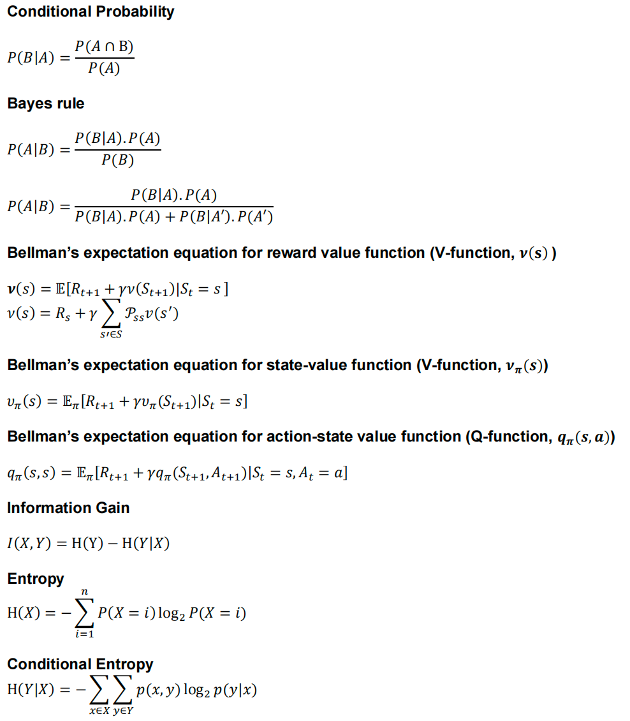

# 默写题

## week1

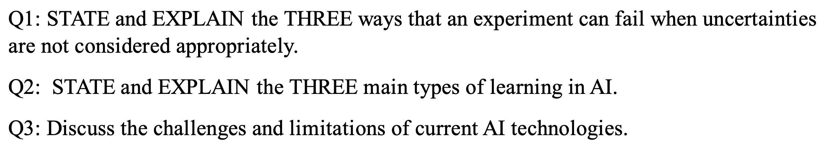

## week2

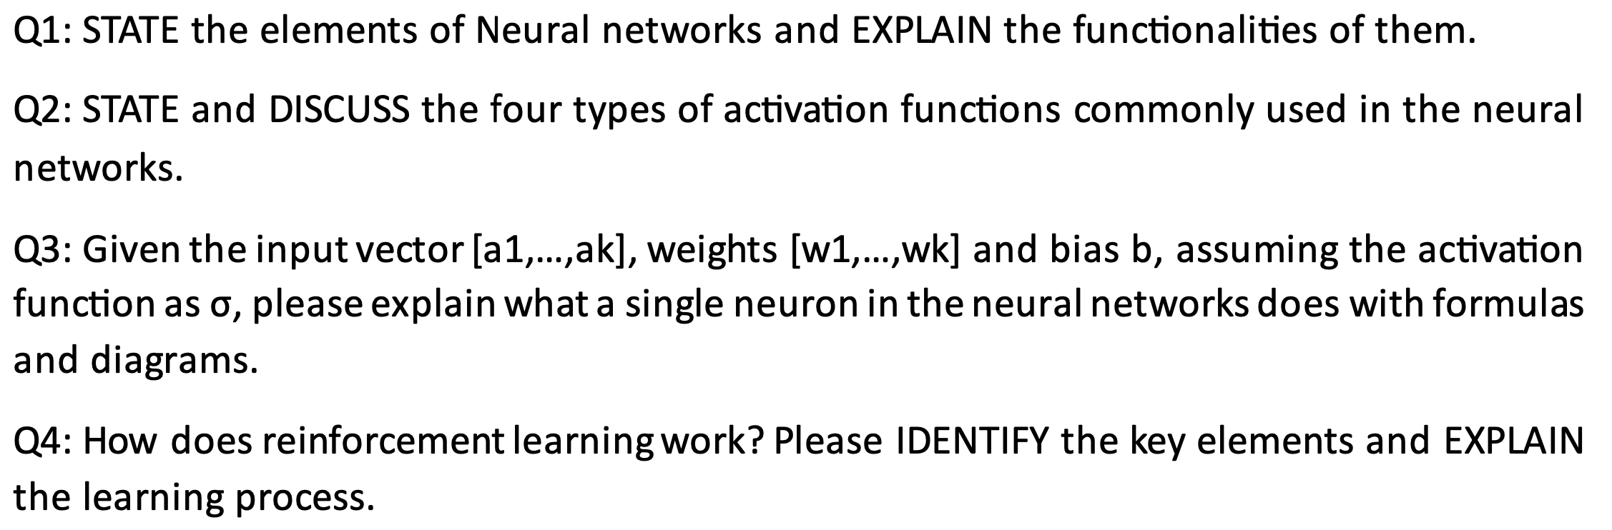

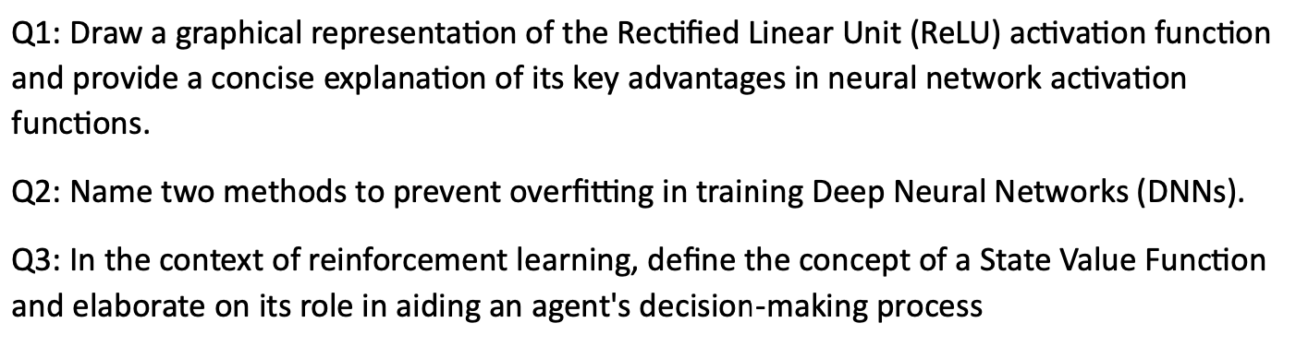

## week3

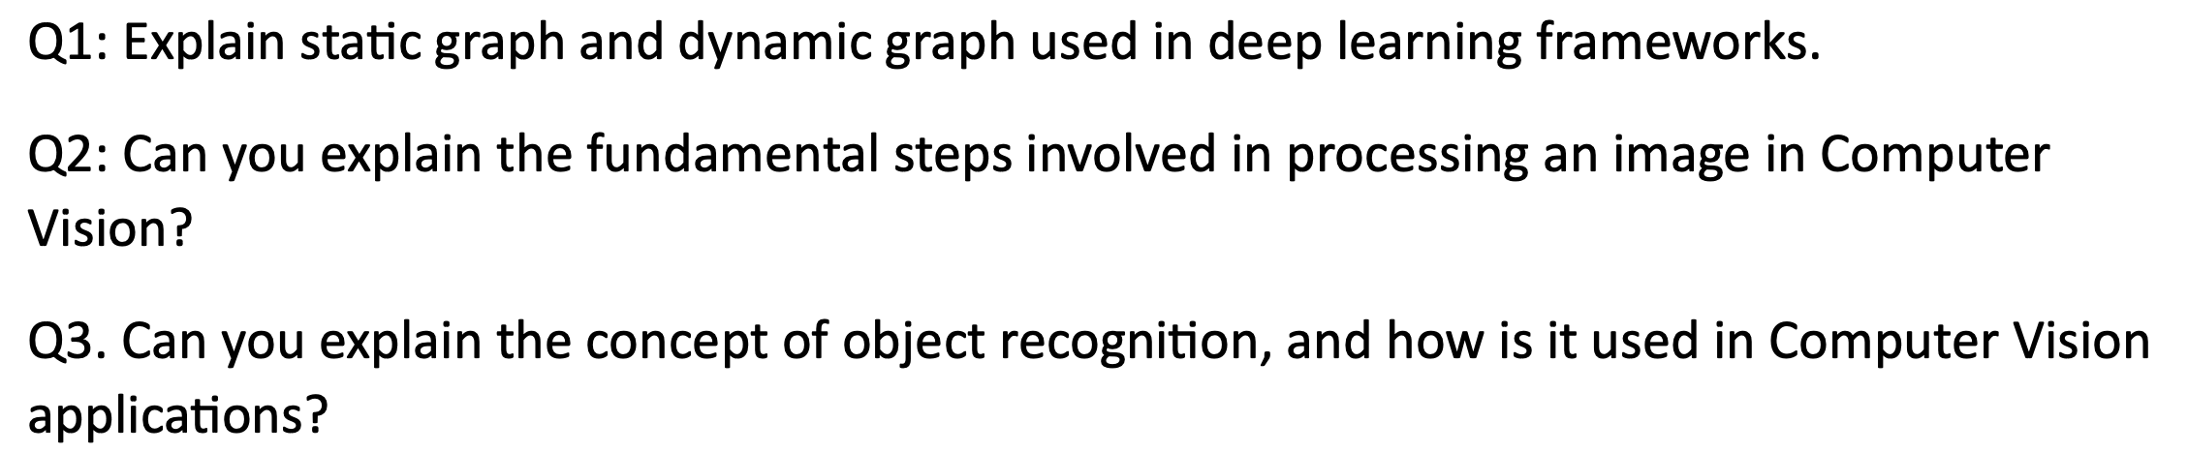

## week4

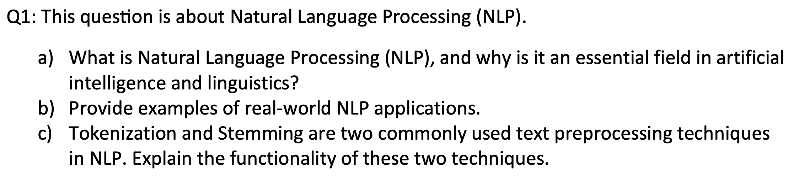

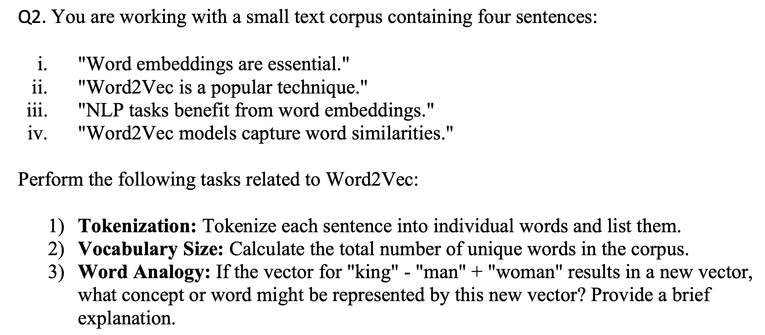

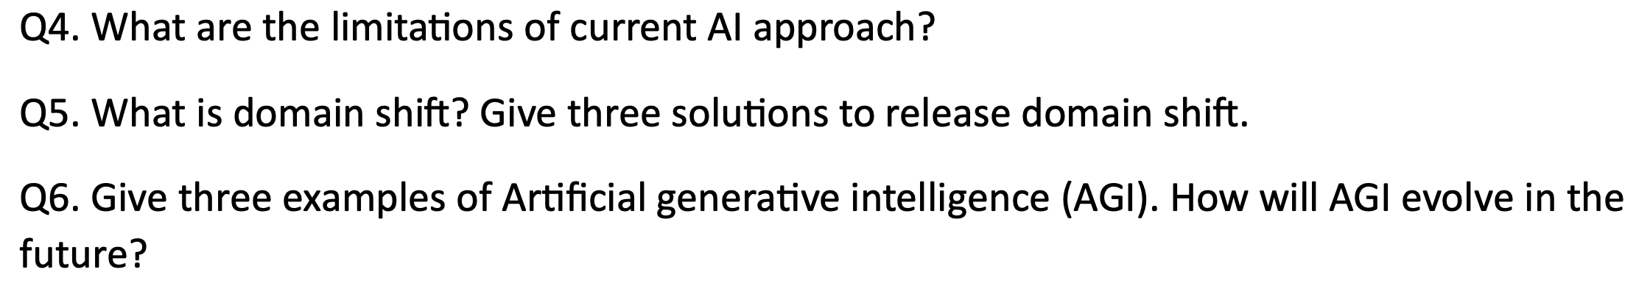

## final

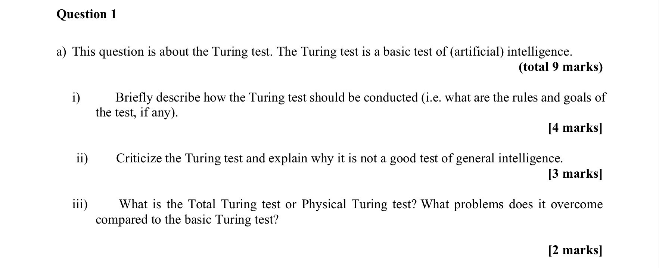

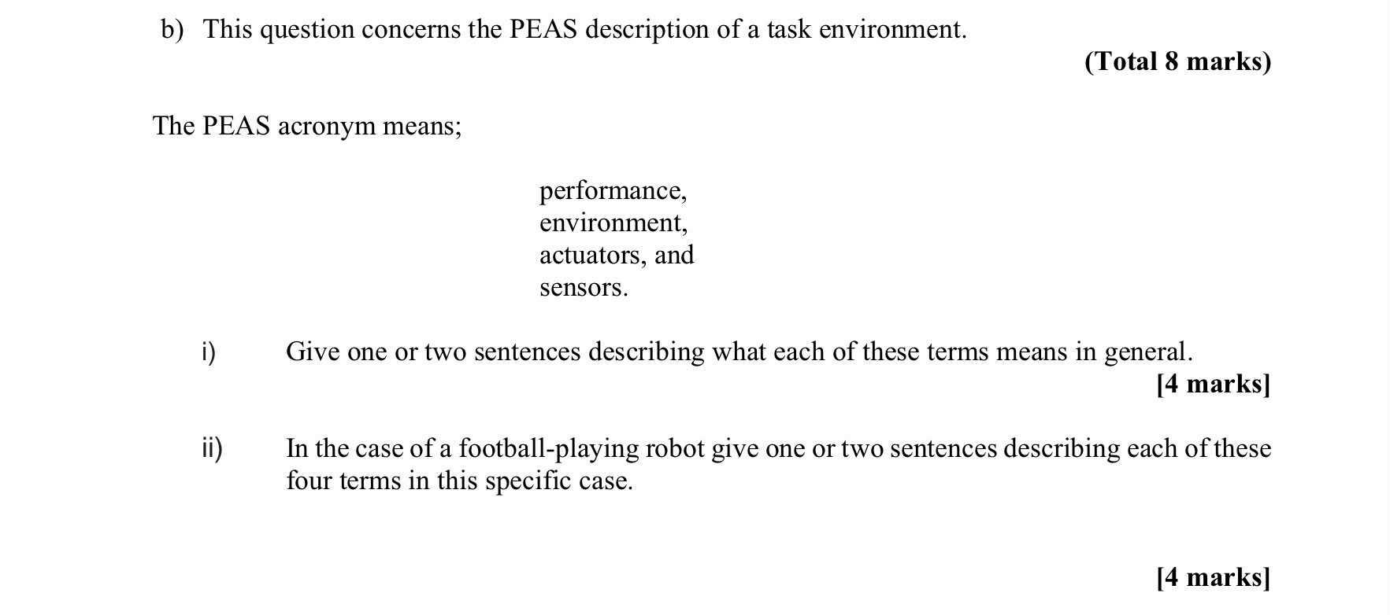

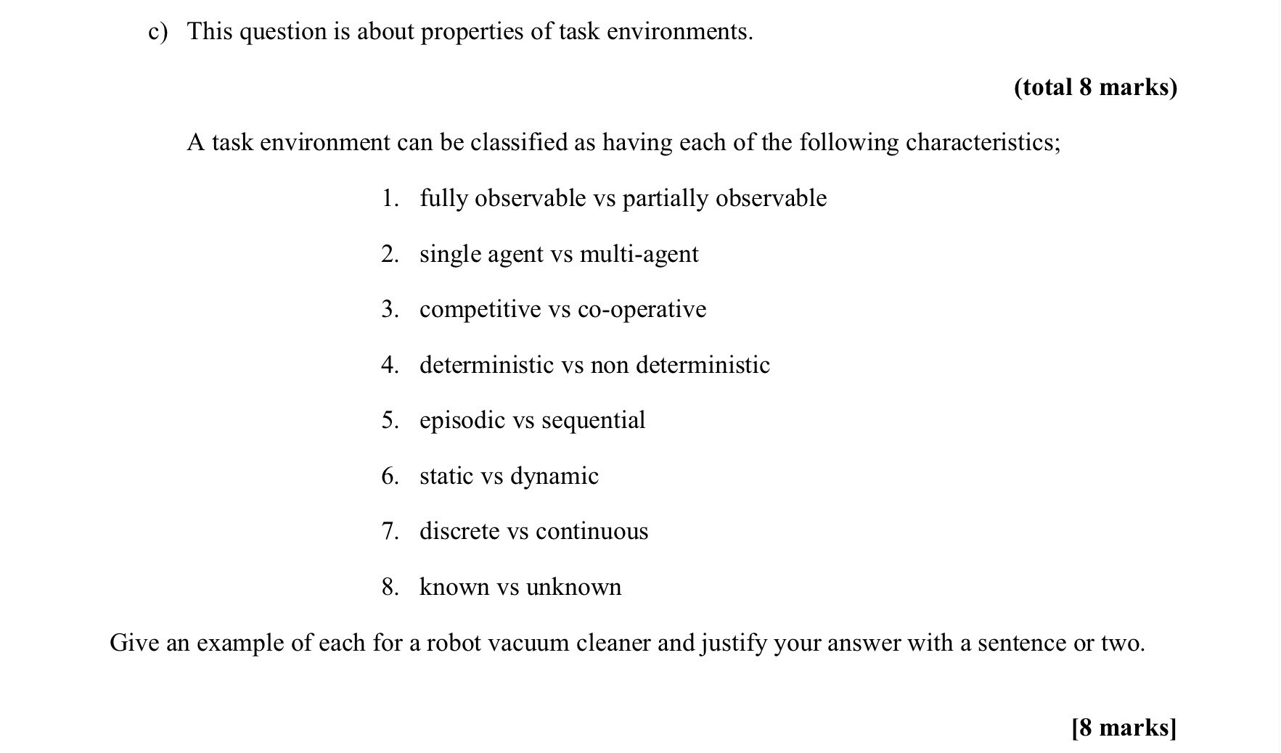

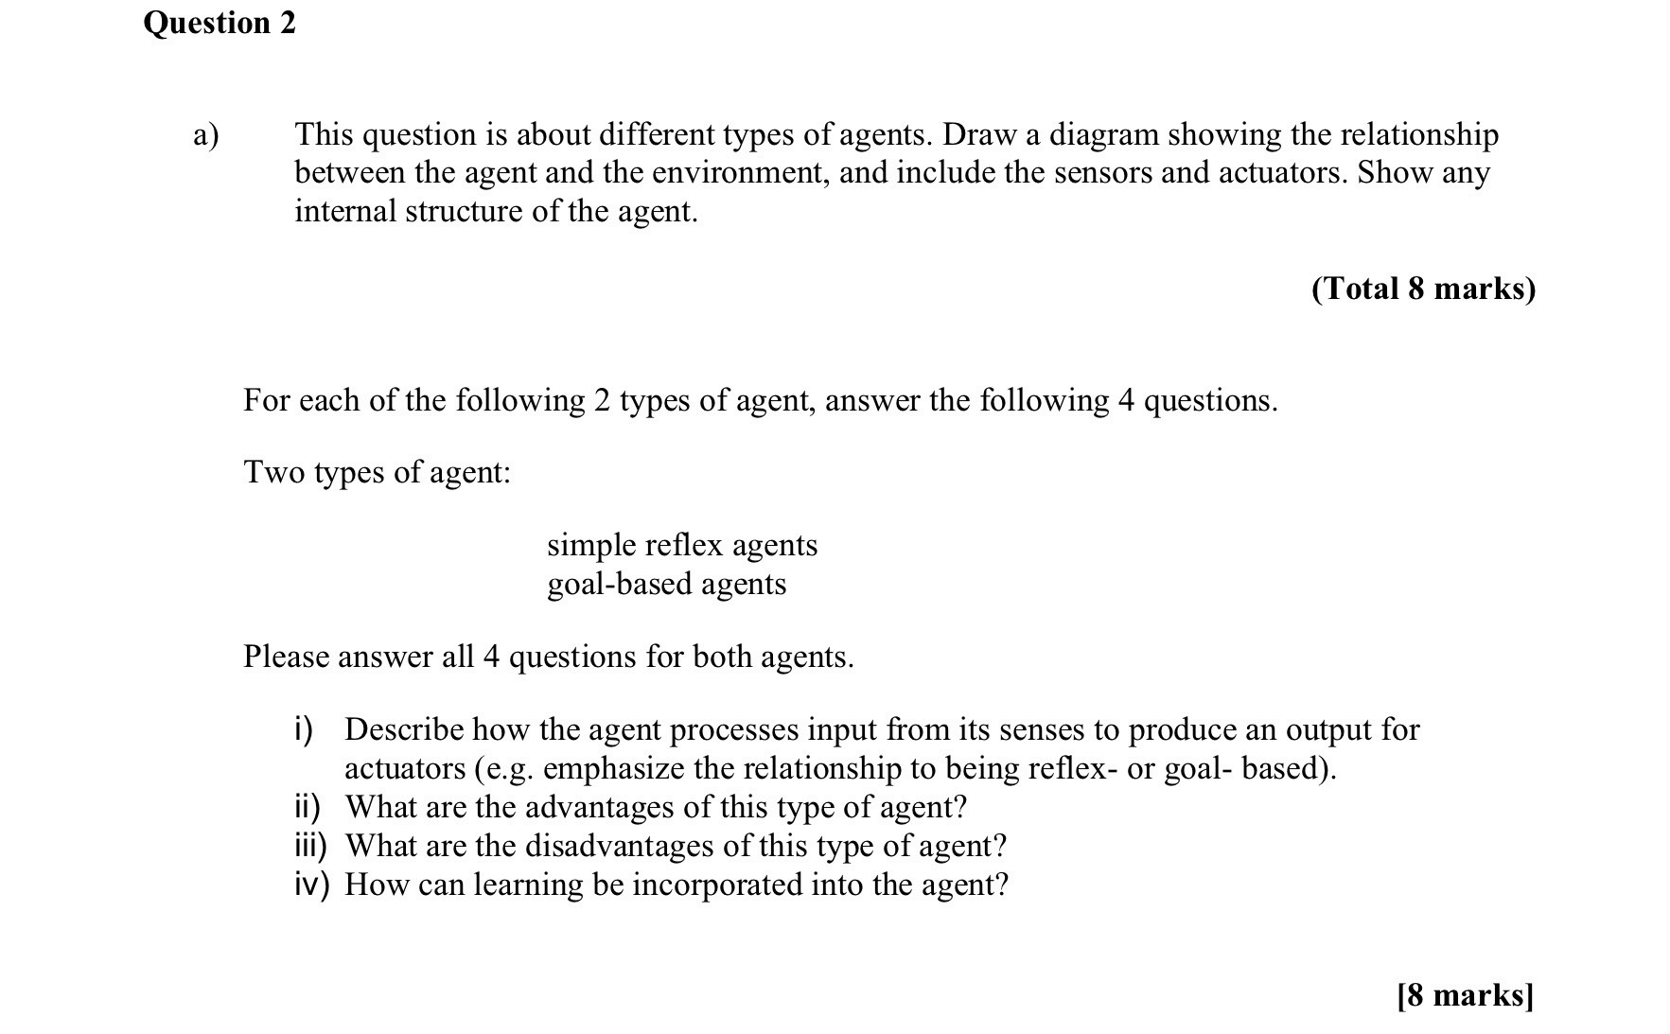

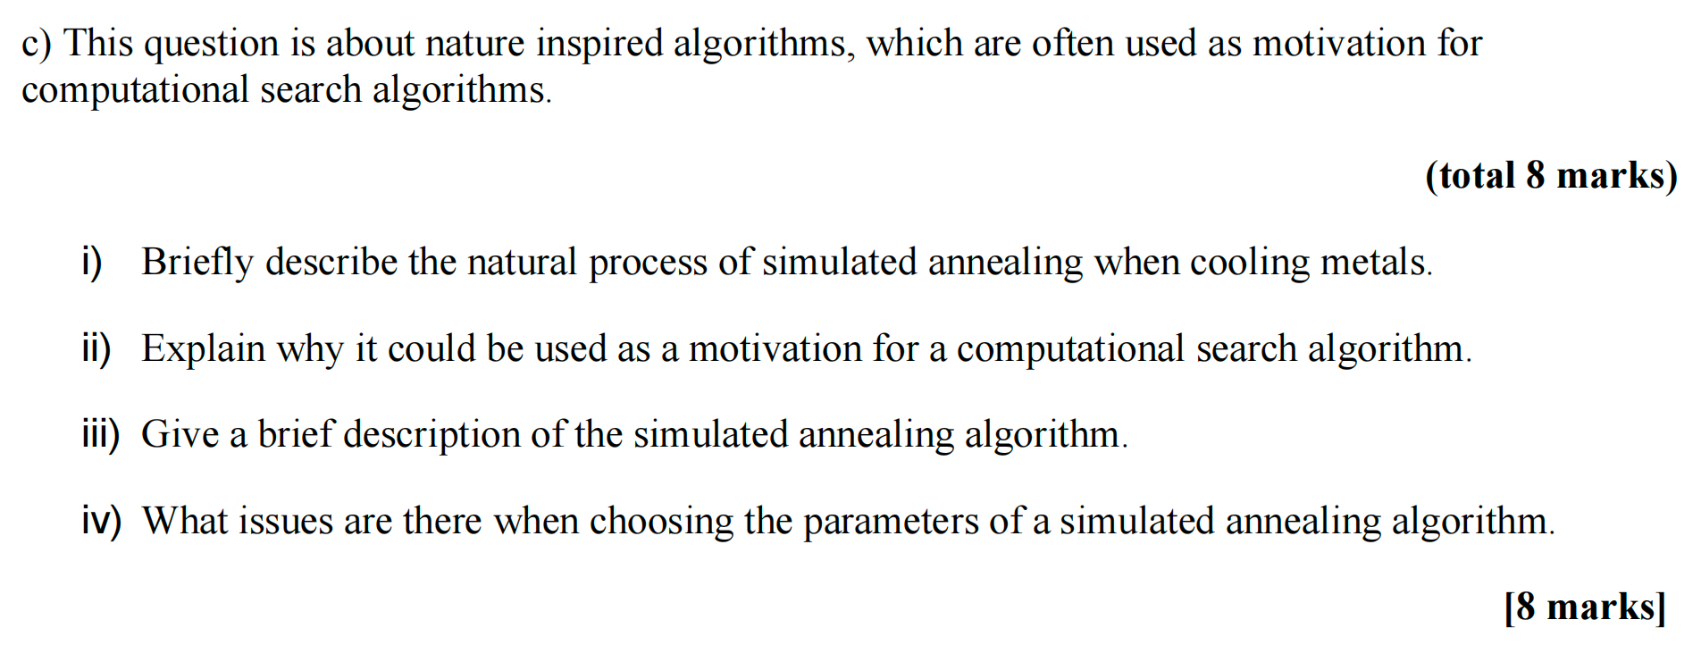

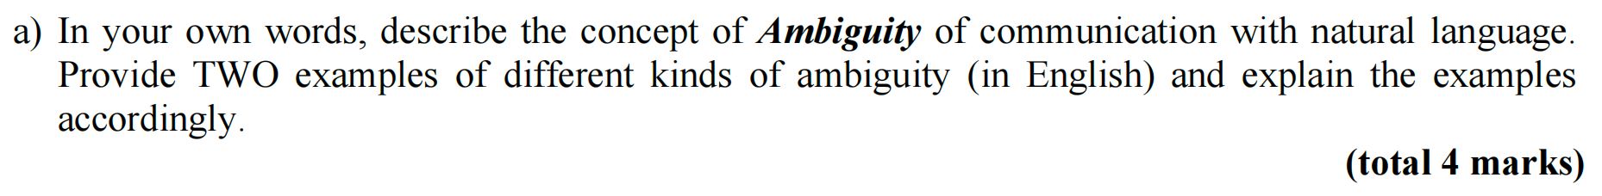

# 计算题

## week1

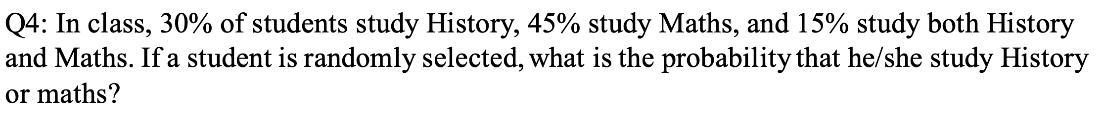

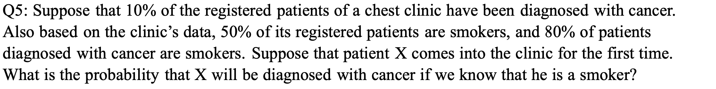

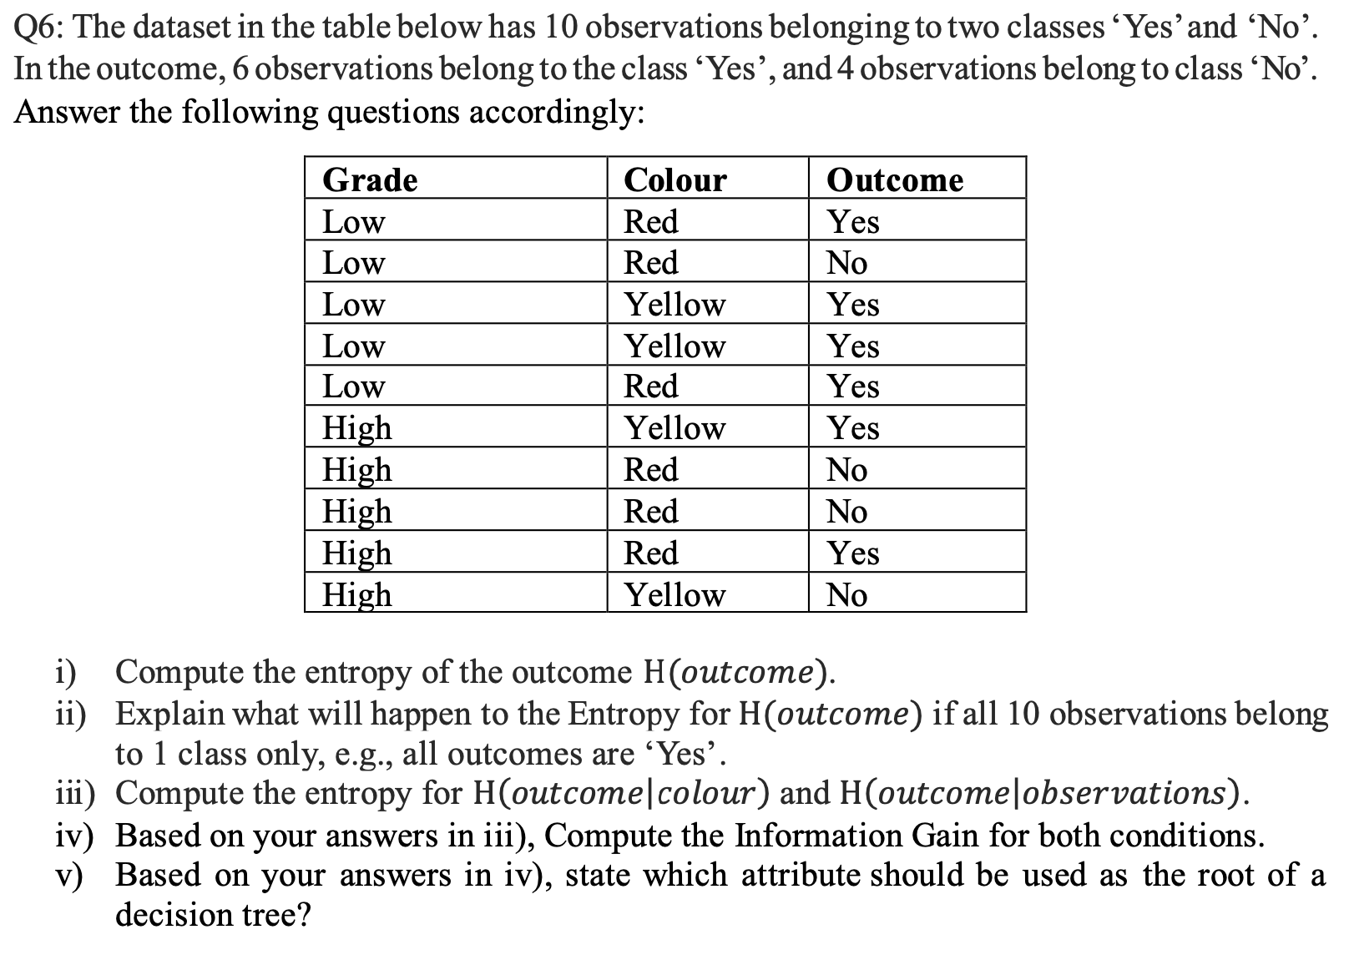

## week2

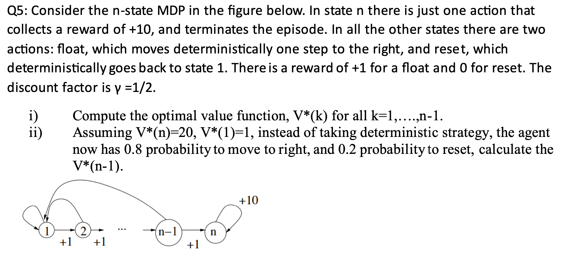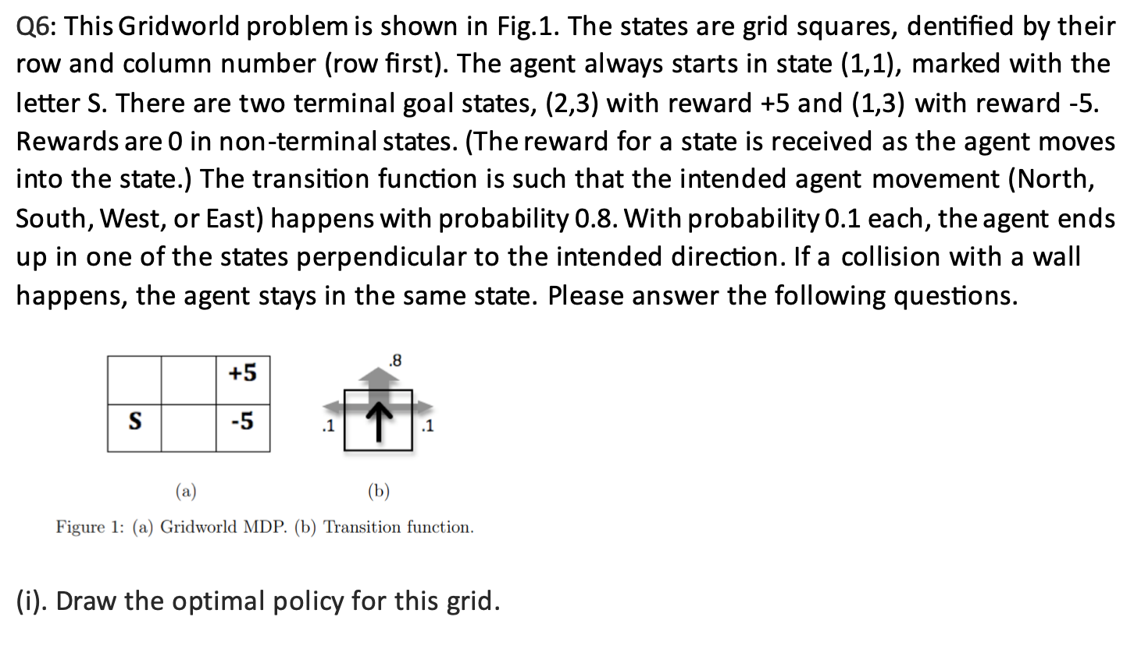

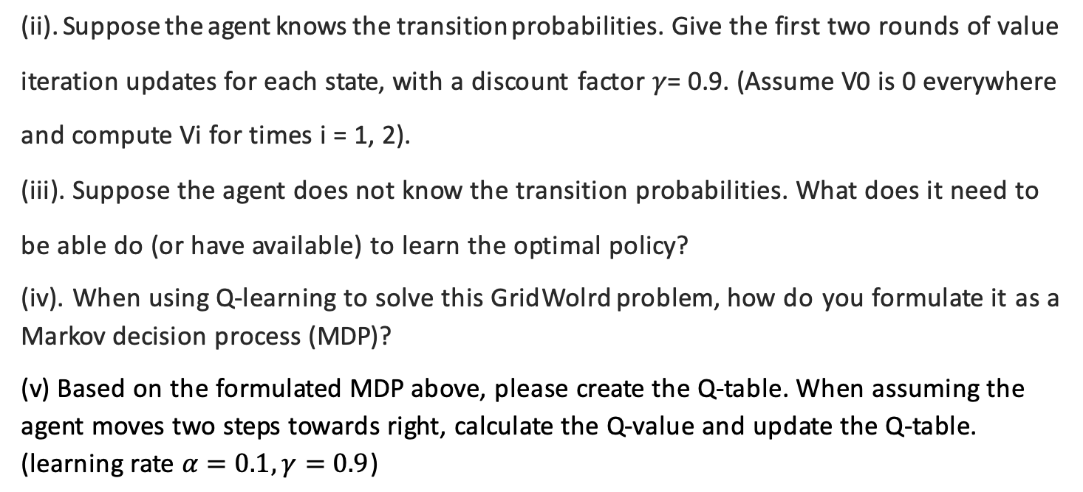

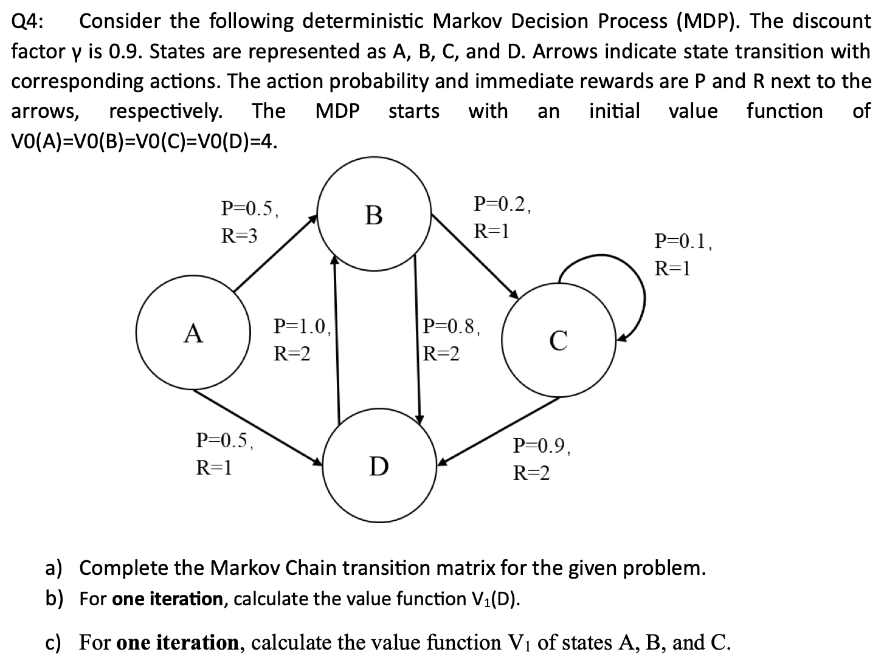

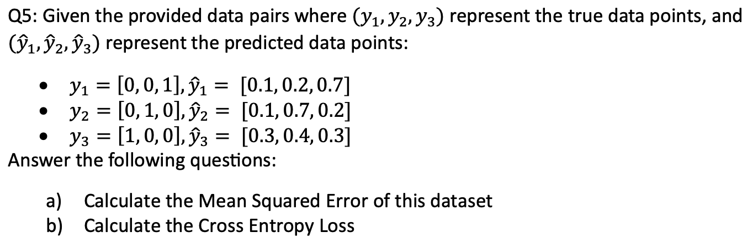

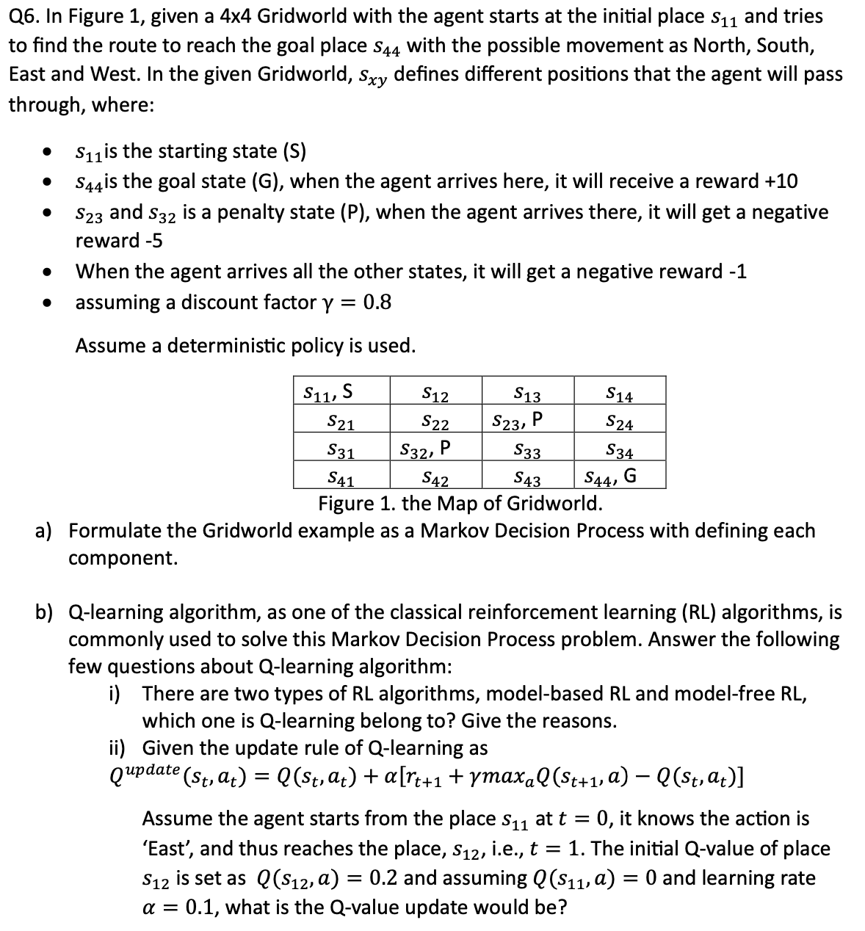

## week3

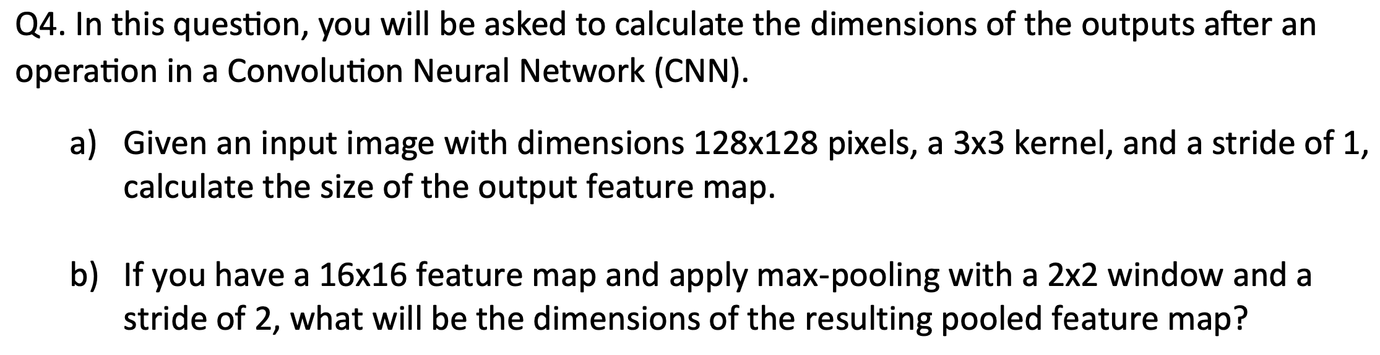

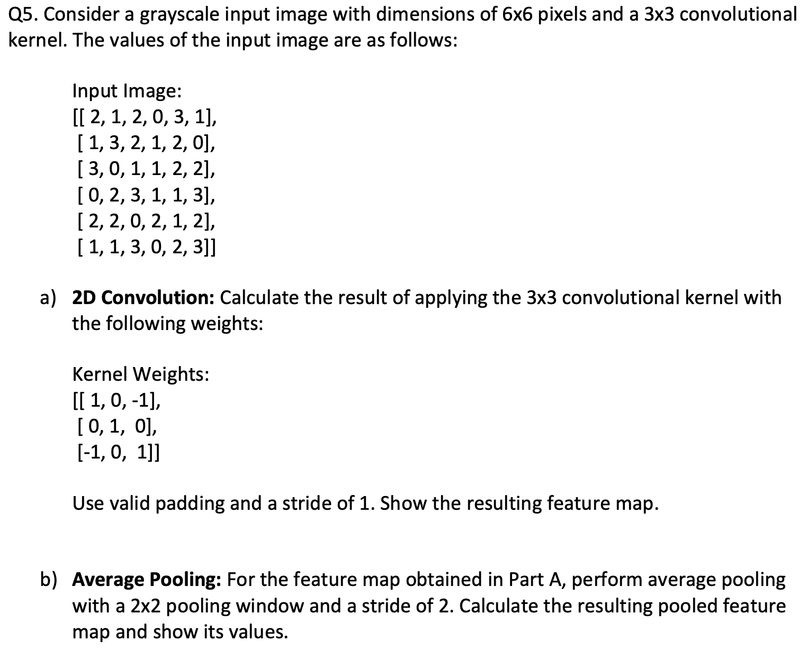

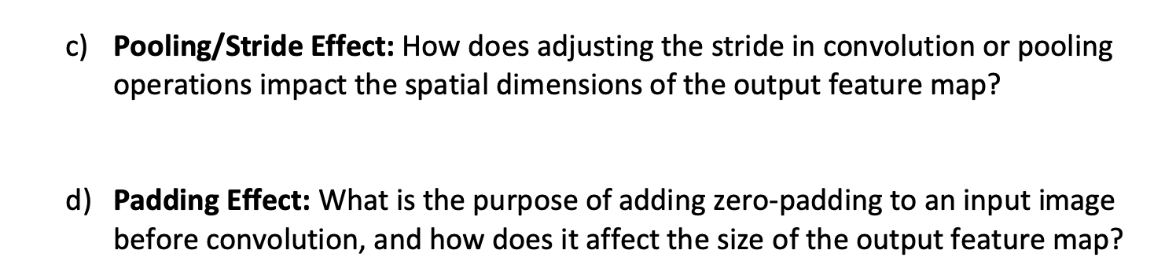

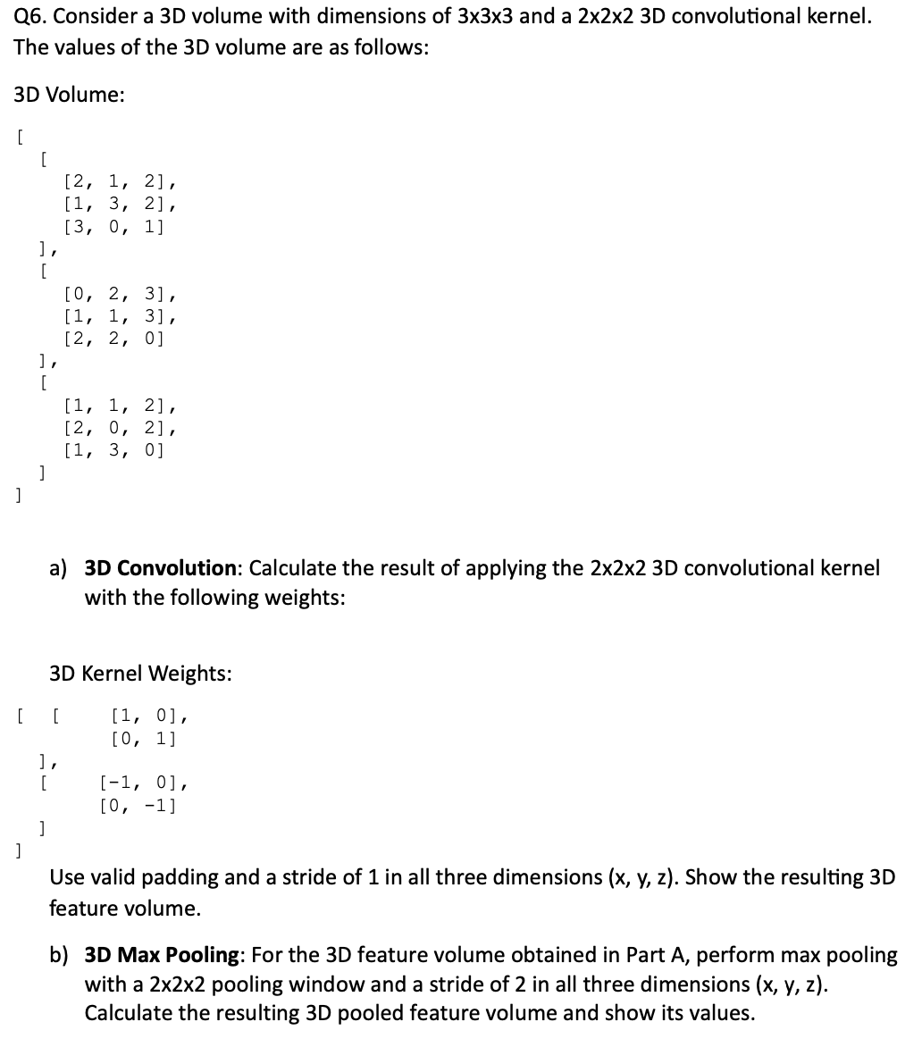

## week4

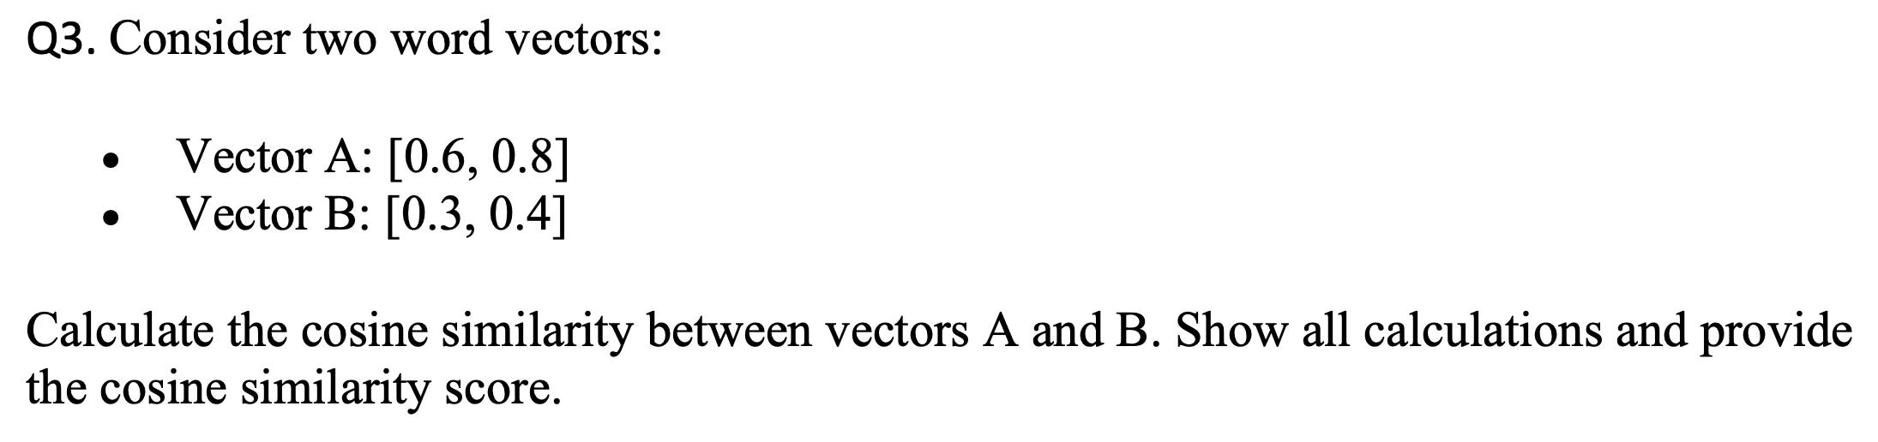

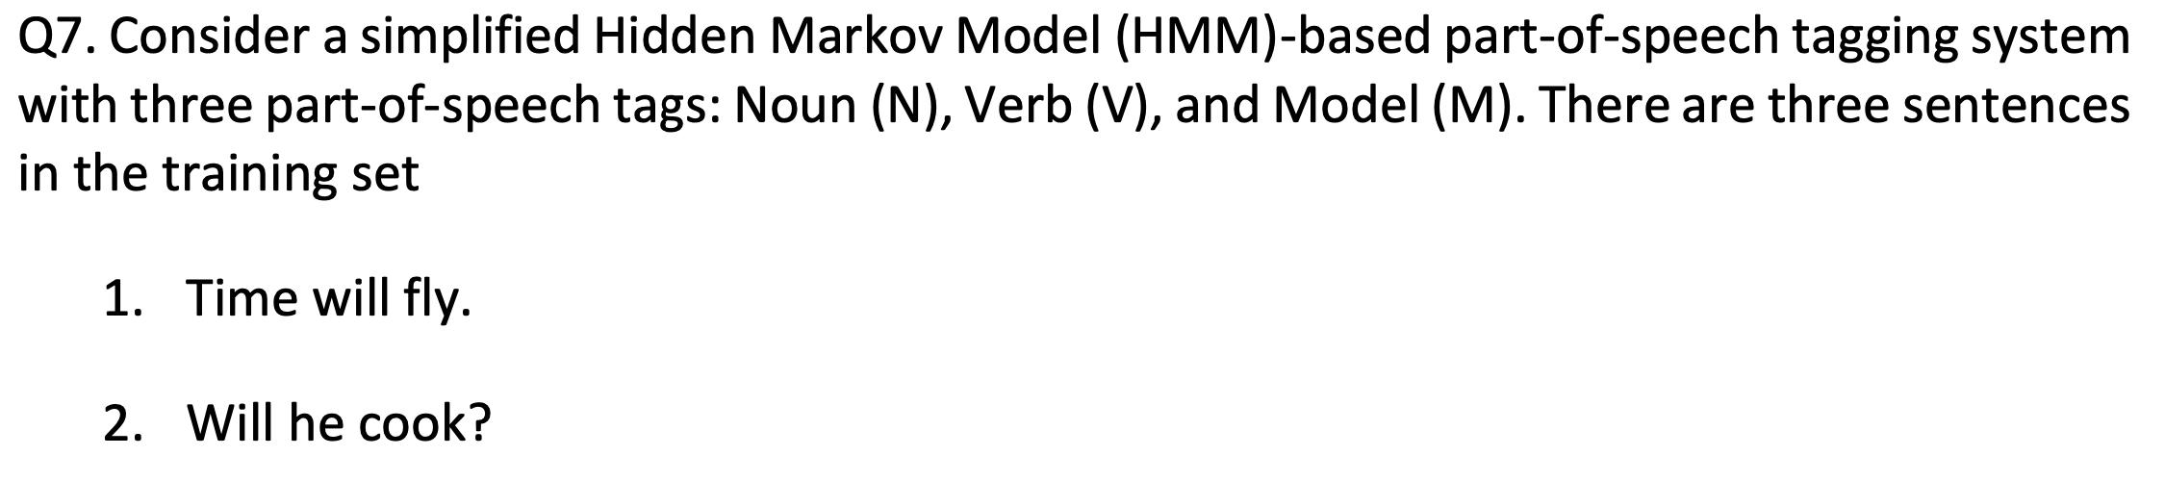

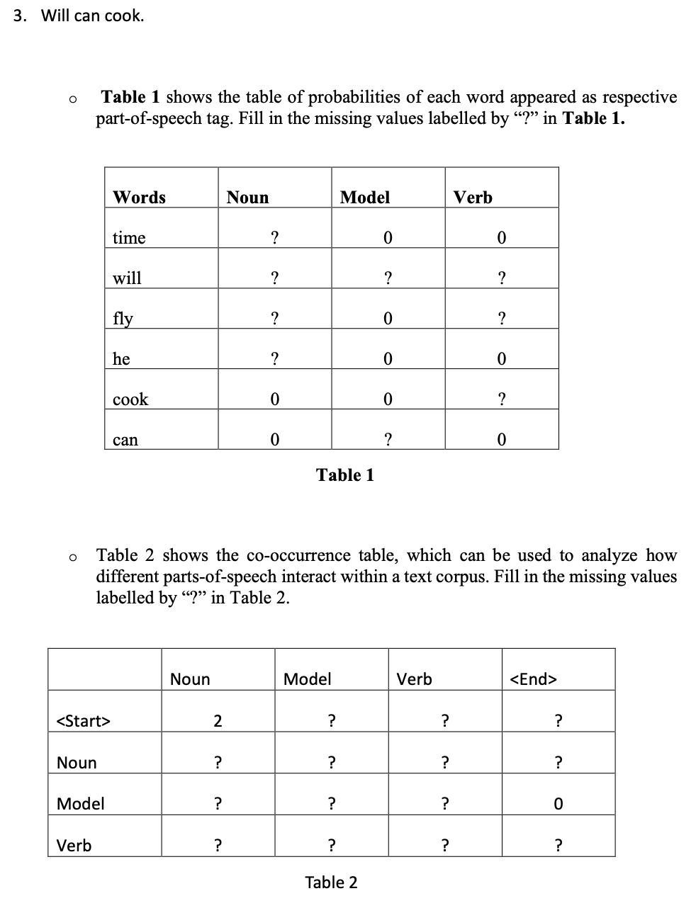

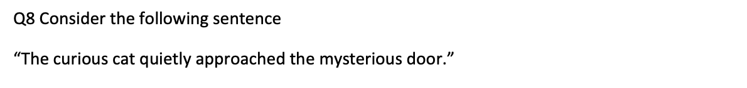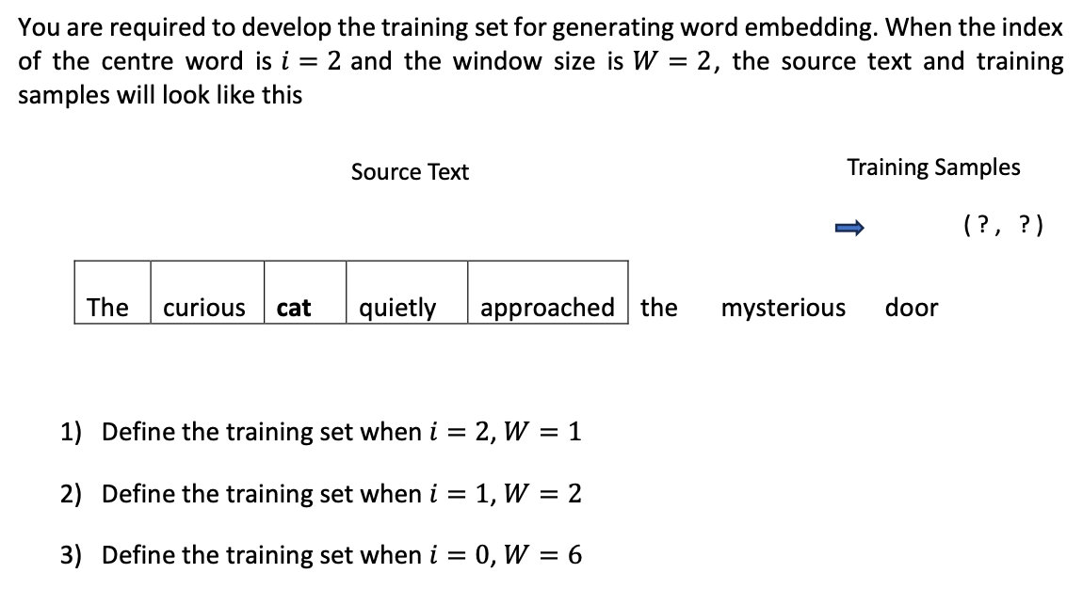

## final

